17th Recruiting for Climate Presenter of The Climate Reality Project, Korea District Office

We are looking for 17th Climate Presenters/Leaders who will passionately devote oneself to 'The Climate Reality Project', an International Environmental NGO by Al Gore.

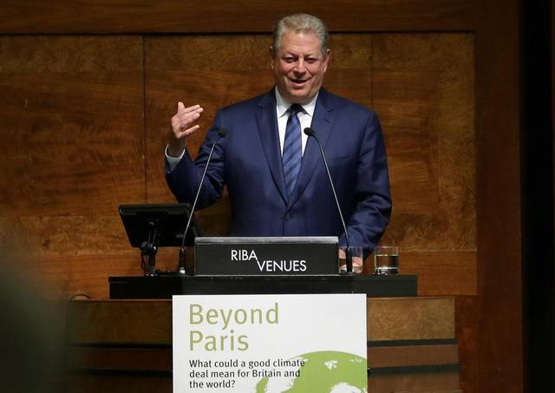
“The reality we now face implores us to act.”
- AL GORE, Founder & Chairman, The Climate Reality Project -

What is TCRP (The Climate Reality Project)?

WE ARE CLIMATE REALITY
In 2006, Nobel Laureate and former US Vice President Al Gore got the world talking about climate change with the Academy Award-winning film An Inconvenient Truth.
It was just the beginning of a climate revolution. Later that year, he founded what would become The Climate Reality Project to move the conversation forward and turn awareness into action all across the Earth.
Today, as Climate Reality, we’re a diverse group of passionate individuals who’ve come together to solve the greatest challenge of our time. We are activists, cultural leaders, organizers, scientists, and storytellers committed to building a sustainable future together.

Area of Recruitment
17th Climate Reality Presenter

Responsibilities
Climate Presenter will take role in spreading public awareness so that our society can face the reality of global climate crisis and motivating them to take action in coping with climate crisis emergency by reminding them that well-being of individuals, families and local communities depend on the way humans come together as one species.

Minimum Qualification
- Those who have large interest in environmental issues and who want to support environment preservation
- Those who are passionate and have a strong sense of responsibility
- Those who are willing to give public education of climate change during the period of Feb. 1. 2024 ~ Jan.31st 2025 with sincerity. (If it is unavoidable, the activity period can be adjusted)
- Age, gender, educational background, occupation and foreign language skills are not important/irrelevant
- Those who have clear perception in security maintenance of internal information and protection of all education data copyrights while participating in climate activist group activities
- Since we have various audiovisual materials for environment education, you don’t have to be an expert in presentation skills.

Preferred Qualification
- Those who have experience in giving climate/environment education speech; planning educational contents; planning and executing school/organization events; participation in planning and hosting international/local campaigns etc.
(Will provide opportunity to participate in TCRP Korea District’s major business areas)
- Those who have skills in Social Media management

Recruitment Schedule
- Application deadline: Sunday January 28, 2024 (Application form must be submitted)
- Announcement of qualified candidates and interview schedule: Individually notified afterward. (We will set up online interview schedules according to registration order.)
- Interview Schedule: Individually notified afterward.
- Final Announcement: Individually announced afterward.
- Orientation Schedule: Will be sequentially proceeded in groups

How to apply: Please fill out a form below.
- 1) Please send the application form attached to climateproject@tcpkorea.org
- (E-mail/File Title: Climate Presenter 17th Application – Name’)
- Or
- 2) Complete and apply through the QR code on the promotional flyer.

MAKE A DIFFERENCE ON CLIMATE CHANGE

WHAT YOU CAN DO NOW
From February 1 2024 to January 31 2025, make a difference and join the Climate Reality Project Korea District Office as a climate reality presenter. Gain the tools, knowledge, and network to help stop global warming and build a more just world for all.

The Climate Reality Project is led by former US Vice President Al Gore. Comes at a critical moment for our planet. Together, the continuing pandemic, growing inequality, and the deepening climate crisis threaten not just our world today, but the future we hand to our children.
This is our moment to change that. We may not get another. It’s time to stand up and make good on our promises to each other, our communities, and our planet.

Be part of something big.
You see our climate changing and injustice growing across the planet.
You want to make a difference.

Join the Climate Reality Leadership Corps of activists. Your chance to learn and act about the climate and justice crises shaping our world – and how you can make a difference.

Action Focus
- The science of climate change and practical solutions
- How the climate crisis is fueling a global health crisis
- Climate and environmental justice around the world
- Effective organizing for climate action
- Connecting natural and technological climate solutions
- COP 29: Making 2024 a year for breakthrough action

WHAT DO I GET BY ATTENDING An act of leadership in climate reality project?
By joining the act of leadership in Climate Reality Project, you’ll gain a deeper understanding of:
- How our climate is changing
- How systemic racism is fueling the climate crisis and deepening injustice
- How we can confront these challenges and build the world we want
- The practical solutions in our hands today

Just as important, by attending our act of leadership, you’ll start building the skills and network to:
- Raise awareness and influence public opinion when it matters
- Inspire your friends, colleagues, and community to take action
- Effectively pressure policymakers to act on bold just climate solutions

FIND YOUR PEOPLE
Join the Climate Reality Korea District Office.
They’re about connecting with other changemakers just like you and building a powerful network of friends, colleagues, and allies to make a difference when it matters.

How to apply: Please fill out a form below.
1. Please send the application form attached to climateproject@tcpkorea.org
(E-mail/File Title: Climate Presenter 17th Application – Name’)
Or
2. Complete and apply through the QR code on the promotional flyer.

Contact
Phone: +82-02-336-0912
Email: climateproject@tcpkorea.org (We prefer e-mail inquiry to telephone. When you send an e-mail, the title should be: Inquiry of 17th Climate Presenter_Name)

